10.91: The initial angular momentum is 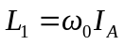 and the initial kinetic energy is 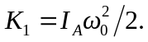 The final total moment of inertia is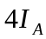, so the final angular velocity is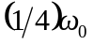and the final kinetic energy is 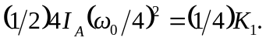(This result may be obtained more directly from 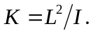Thus,
